Impact Report Highlights
2022 Accomplishments
and 2023 Goals

Environment

MAKING PROGRESS TOGETHER

2022 was a year of incredible growth, challenge, and opportunity. While taking great care of customers, clients, partners and team, Dwellworks also made significant progress in our ESG initiatives, through a globally reduced carbon footprint, the environmentally responsible actions of the partners in our supplier network, and the worldwide commitment and actions of our associates in building a more diverse, equitable, inclusive and connected company.

Dwellworks is aligned with the Coalition for Greener Mobility to simplify and standardize sustainability programs and practices in relocation and business travel. We are pleased to contribute our expertise in good governance and global destination services and corporate housing to this broader industry effort.

We invite you to read on to learn how our investment in ESG is spurring better results for clients, customers, associates, network partners, investors, and community. To access the full Impact Report, contact us at esg@dwellworks.com
2023 Goals

2022 Accomplishments
Fund an annual donation on customers’ behalf
Build V1 database of active eco-friendly corporate housing suppliers

36%
global reduction in Scope 2
GHG emissions

84%
corporate housing survey
respondents taking sustainable actions

15%
local destination
consultants use low- carbon emissions cars

100%
technology hardware
recycling and reuse

$10K
Define a high impact/BHAG Environmental action for our teams
Continue to measure GHG emissions reductions on a global scale
donation to Conservation
International on behalf of customers

- registered with UN Global Compact
- participants in Coalition for Greener Mobility
Lead or co-lead a minimum of one key sustainability project for Coalition for Greener Talent Mobility

Social

2022 Accomplishments

2023 Goals

300+
positive associate responses
to peer recognition survey

73%
women on Dwellworks
team

60%
women/LGBTQ+ representation
on executive team
85%
destination consultants
identify as women

47%
corporate housing partner owners
identify as women

$10K
donation to Habitat for
Humanity
Embed workforce diversity best practices in recruiting/ development

Expand myDwellworks inclusionary content to Consultants and team
Fund an annual donation on customers’ behalf

Define a high impact BHAG/ Social action for our teams

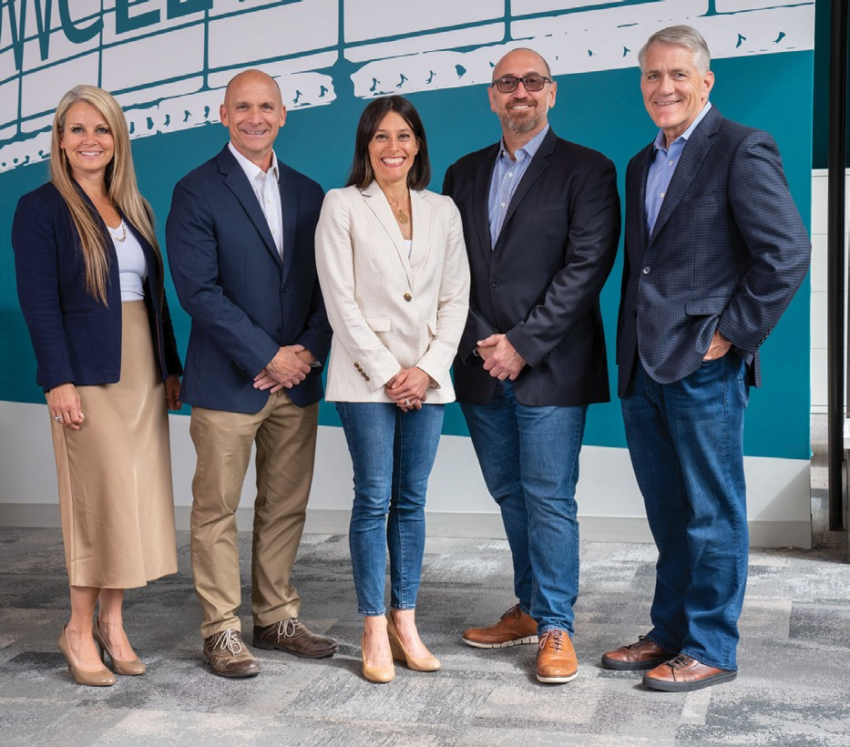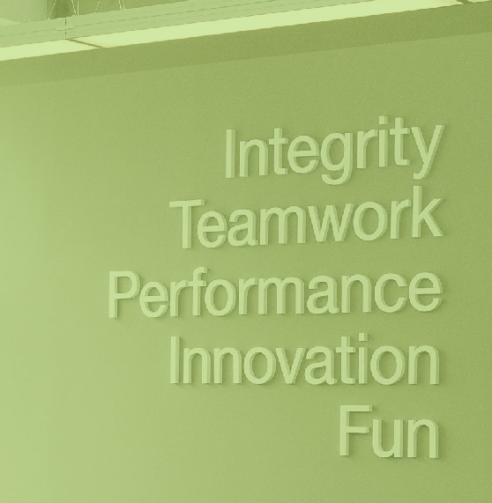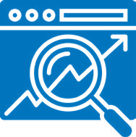
2023 Goals
Implement V1 tracking of diverse and sustainably supportive supplier spend
Renew EcoVadis certification
Align with new regulatory and compliance directives
Update UN Global Compact Communication on Progress (CoP)

Governance

2022 Accomplishments

100%
associate completion of mandatory ethics, compliance,
and ESG training (US)

EcoVadis Silver Medal – top 25% of 75,000+ companies

enrolled in UN Global Compact

successfully completed SOC-2 audit

For more information: esg@dwellworks.com

